**DMAIC**

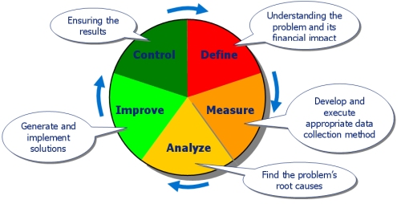

**Define**

The purpose of this step is to clearly articulate (rõ ràng) the business problem, goal, potential (tiềm năng) resources, project scope and high-level project timeline. This information is typically captured (nắm bắt được) within project charter document. Write down what you currently know. Seek to clarify facts (làm sang tỏ vấn đề), set objectives and form the project team. Define the following:

* A problem
* The customer(s)
* [Critical to Quality](http://en.wikipedia.org/wiki/Critical_to_Quality) (CTQs) — what are the critical process outputs?
* The target process subject to DMAIC and other related business processes
* Project targets or goal
* Project boundaries or scope
* A project charter is often created and agreed upon (được thỏa thuận) during the Define step.

**Measure**

The purpose of the Measure phase is to fully understand the current performance by identifying how to best measure current performance and to start measuring it. The measurements used should be useful and relevant to identifying and measuring the source of variation (nguồn gốc sự biến đổi)**.** Focus the improvement effort by gathering information on the current situation

* Identify the gap (khoảng cách) between current and required performance.
* Collect data to create a process performance capability (khả năng hiệu quả của quy trình) baseline for the project metric, that is, the process Y(s) (there may be more than one output).
* Assess (đánh giá) the measurement system for adequate accuracy and precision (đủ chính xác)
* Establish a high level process flow baseline. Additional detail can be filled in later.

**Analyze**

In the Analyze phase, the measurements collected in the Measure phase are analyzed so that hypotheses (giả thiết) about the root causes of variations in the measurements can be generated (tạo ra ) and the hypothesis subsequently validated. It is at this stage that practical business problems are turned into statistical problems and analyzed as statistical problems

Identify deep root causes and confirm them with data

* List and prioritize potential causes of the problem
* Prioritize the root causes (key process inputs) to pursue in the Improve step
* Identify how the process inputs (Xs) affect the process outputs (Ys). Data is analyzed to understand the magnitude (cường độ) of contribution of each root cause, X, to the project metric, Y.
* Detailed process maps can be created to help pin-point where in the process the root causes reside (cư trú), and what might be contributing (đóng góp) to the occurrence (xảy ra)

**Improve**

The purpose of this step is to identify, test and implement a solution to the problem; in part or in whole. (một phần hoặc toàn bộ) Identify creative solutions to eliminate the key root causes in order to fix and prevent process problems. Use brainstorming or techniques like [Six Thinking Hats](http://en.wikipedia.org/wiki/Six_Thinking_Hats) and [Random Word](http://en.wikipedia.org/wiki/Random_stimulus). Some projects can utilize(sử dụng) complex analysis tools like DOE ([Design of Experiments](http://en.wikipedia.org/wiki/Design_of_Experiments)), but try to focus on obvious solutions if these are apparent.(tập trung vào giải pháp rõ ràng)

* Create innovative solutions
* Focus on the simplest and easiest solutions
* Test solutions using [Plan-Do-Check-Act](http://en.wikipedia.org/wiki/PDCA) (PDCA) cycle
* Based on PDCA results, attempt to anticipate any avoidable risks associated with the "improvement" using [FMEA](http://en.wikipedia.org/wiki/Failure_mode_and_effects_analysis) (dự đoạn rủi ro trong lúc cải thiện bằng FMEA)
* Create a detailed implementation plan
* Deploy improvements

**Control**

The purpose of this step is to sustain the gains (duy trì lợi nhuận). Monitor the improvements to ensure continued and sustainable success. Create a control plan. Update documents, business process and training records as required.

A [Control chart](http://en.wikipedia.org/wiki/Control_chart) can be useful during the control stage to assess the stability of the improvements over time

**DMADV**

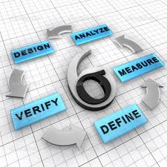

The acronym DMADV sounds pretty much similar to DMAIC. The similarity ends after the first three letters DMA

**1.      Define**: You will define the goals of the project and that of the customers (both internal and external)

**2.      Measure**: Here you will quantify the customer needs as well as the goals of the management

**3.      Analyze**: Analyze the options, existing process to determine the cause of error origination and evaluate corrective measures

**4.      Design**: Design a new process or a corrective step to the existing one to eliminate the error origination that meets the target specification

**5.      Verify**: Verify, by simulation or otherwise, the performance of thus developed design and its ability to meet the target needs

* ***D****efine* (xác định) mục tiêu thiết kế nhằm phù hợp với yêu cầu của khách hàng và chiến lược của công ty.
* ***M****easure* (đo lường) và nhận ra CTQs (viết tắt của **C**ritical **T**o **Q**uality - giới hạn cho chất lượng), khả năng sản xuất, khả năng của dây truyền sản phẩm và những rủi ro.
* ***A****nalyze* (phân tích) nhằm phát triển và thiết kế những phương án khác.
* ***D****esign* (thiết kế) và nâng cao các phương án khác nhau, nhằm phù hợp nhất trong mỗi bước phân tích trước đó.
* ***V****erify* (xác nhận) thiết kế, chạy thử, áp dụng cho dây truyền sản xuất và bàn giao nó cho chủ sở hữu.

**How are DMAIC and DMADV Similar?**

* Six Sigma methodologies used to drive defects to less than 3.4 per million opportunities
* Data intensive solution approaches. Intuition has no place in Six Sigma
* Implemented by Green Belts, Black Belts, Master Black Belts
* Way to help meet the business / financial bottom-line number
* Implemented with the support of champion and process owner

**How are DMAIC and DMADV Different?**

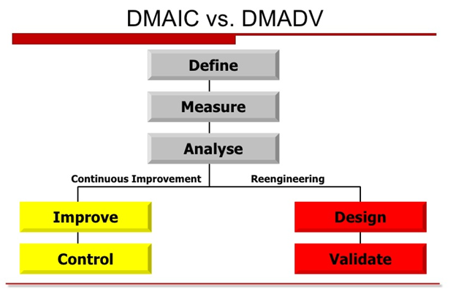

DMAIC concentrates on making improvements to a business process in order to reduce or eliminate defects; DMADV develops an appropriate business model destined to meet the customers’ requirements.

DMAIC tập trung vào việc cải thiện quy trình kinh doanh để giảm thiểu số defect còn DMADV tập trung phát triển mô hình kinh doanh phù hợp với yêu cầu của khách hàng

Despite the shared first three letters of their names, there are some notable differences between them.  The main difference exists in the way the final two steps of the process are handled.  With DMADV, the Design and Verify steps deal with redesigning a process to match customer needs, as opposed to the Improve and Control steps that focus on determining ways to readjust and control the process.   DMAIC typically defines a business process and how applicable it is; DMADV defines the needs of the customer as they relate to a service or product.

Sự khác biệt chính tồn tại trong cách hai bước cuối cùng của quy trình. Với DMADV, Design và Validate dùng để thiết kế lại một quá trình để phù hợp với nhu cầu khách hàng, còn DMAIC thì Improve và Control tập trung vào việc xác định cách làm thế nào để điều chỉnh và kiểm soát quy trình. DMAIC thường định nghĩa một quá trình kinh doanh và làm thế nào áp dụng nó là; DMADV xác định nhu cầu của khách hàng có liên quan đến một dịch vụ hoặc sản phẩm

With regards to measurement, DMAIC measures current performance of a process while DMADV measures customer specifications and needs.

Liên quan bước measurement DMAIC thường đo lường về hiệu suất hiện tại của một quy trình trong khi DMADV đo lường chi tiết kỹ thuật và nhu cầu của khách hàng.

**When Should DMAIC and DMADV Be Used?**

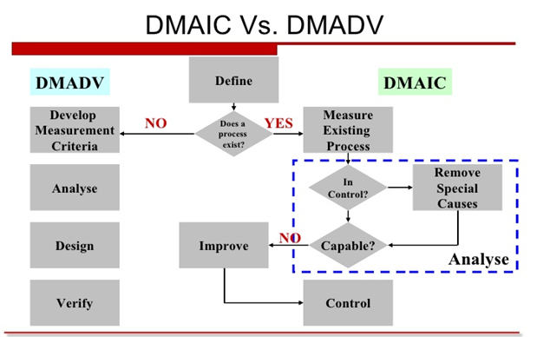

**When to use DMAIC**

Used when a product or process is in existence and is not meeting customer specification or is not performing adequately

**When to use DMADV**

A product or process is not existence and one needs to be developed

The existence product or process exist and has been optimized and still doesn’t meet the level of customer specification or six sigma level

**DMAIC Tools**

|  |  |
| --- | --- |
| **Project Phase** | **Candidate Six Sigma Tools** |
| **Define** | * Project charter * VOC tools (surveys, focus groups, letters, comment cards) * Process map * QFD * SIPOC * Benchmarking * Project planning and management tools * Pareto analysis |
| **Measure** | * Measurement systems analysis * Process behavior charts (SPC) * Exploratory data analysis * Descriptive statistics * Data mining * Run charts * Pareto analysis |
| **Analyze** | * Cause-and-effect diagrams * Tree diagrams * Brainstorming * Process behavior charts (SPC) * Process maps * Design of experiments * Enumerative statistics (hypothesis tests) * Inferential statistics (Xs and Ys) * Simulation |
| **Improve** | * Force field diagrams * FMEA * 7M tools * Project planning and management tools * Prototype and pilot studies * Simulations |
| **Control** | * SPC * FMEA * ISO 900× * Change budgets, bid models, cost estimating models * Reporting system |